‘Promoted for and on behalf of Cycling Time Trials under their Rules and Regulations’

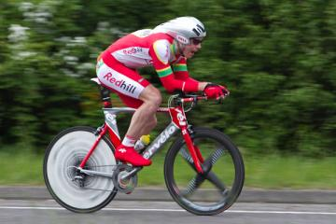
Redhill Cycling Club
18 mile “Sporting” Time Trial – GS/478
Sunday 26 February 2023 at 09.00
Event Secretary: Alison Steel
redhillcctt@gmail.com
07799663245 (for contact on the day)
19 Linnell Road
Redhill, RH1 4DH
Headquarters: St John’s Hall
Furlong Road
Wescott, RH4 3PP
Timekeepers: Paul Tunnell
Mick Irons
Signing on:
- Opens at 08.10 (first rider off 09.01)
- Sign -on and start numbers at Event HQ
- Clothing and numbers are to be worn in conjunction with Regulation 16 and no time may be recorded if number is not correctly positioned
- Allow 5 minutes from HQ to START, turn right heading west on A25 out of HQ (approximately 0.5 miles)
Signing out:
● In type A events a competitor must return to the event HQ during the event or within a reasonable time after the last rider has finished the event and must:
- Return their race number(s) and
- Sign the official Signing-out Sheet
Safety instructions:
● Key CTT Regulations:
1. CTT regulations require the use of a helmet that meets internationally accepted safety standards for all competitors and is properly fitted, is undamaged and is in good condition (reg. 15).
2. CTT Regulations require that no competitor shall be permitted to start either a Type A or Type B event unless such competitor has affixed to the rear of their machine a working rear red light, and to the front of their machine a working front white light, either flashing or constant, that are illuminated and positioned to be clearly visible to other road users (reg. 14 (j)).
It is not the Timekeepers responsibility to check this. The “pusher off” or other observer can note and draw to the rider’s attention the fact that they will be recorded as DNS if they are not in compliance.
3. Competitors are requested not to warm up on the course after the first rider has started.
4. Official Observers will be stationed around the course (See CTT guidance notes 4).
5. Competitors must not use ANY audio equipment except prescribed hearing aids and a competitor in breach of this regulation will be disqualified. Competitors must not use a mobile phone while mounted on their machines (reg. 19).
6. Under 18 age entries must download a parental consent in order to complete on-line entry. These must be present before signing on. No parental consent. No ride.
● London South District Regulations and recommendations:
1. No vehicles, except those of the Timekeepers and Event Officials, shall be parked in the vicinity of the start and finish areas.
2. It is strongly recommended that riders do NOT wear black or dark clothing during any event held on the public road.
● Details of any additional hazards not listed on the start sheet will be displayed at the signing-on point. All competitors must read these details when they sign on.
● The road surface on the course has deteriorated significantly in recent years and there are now a number of potholes and areas of very rough road on the course.
In particular, the descent just after the Punchbowl Pub in Oakwood Hill and back up to the A29 there are a number of potholes and ruts scattered on this section.
● At the time of writing at 5.6 miles there are road works to create parking for residents by narrowing the road at Pitland Street between The Holmbury Garage and Pitland Street and traffic is managed by traffic signals. On TT day, there will be marshals in place regardless of the completion of the works because of the new road layout.
Please exercise extreme care. Remember it is February and use common sense when choosing what tyres to ride with.
● No times will be given at the finish.
Specific to the event:
●due to the number of novice riders in this event with no prior times to assist with seeding, riders’ attention is drawn to the regulations that govern Time Trials and which prohibit drafting (taking shelter behind another rider) (reg. 20).
Parking:
● The HQ is located at St Johns Hall in Wescott (http://www.stjohnswestcott.org.uk/find-us.html, there is no parking available here. It is very near to Nirvana Cycles in the centre of Westcott W3W///hike.sing.green
● Free public car park between Dorking and Westott on A25 – Milton Heath and The Nower Car Park W3W///frame.carbon.evenly
When the car park is full please park considerately and DO NOT block driveways. Use common send when parking and act with respect towards local residents and other road users.
PLEASE RESPECT THE SURROUNDING HOUSEHOLDERS AND PARK WITH CARE
Prizes:
Prize list | 1st
Men | £25
Women | £25
Road Bike | £25
RCC rider | £25

Road Bike Competition
(If you intend to enter the Road Bike category, please tell the signing-on sheet volunteer)
To be eligible for this competition you must be riding a bicycle that has:
- Drop Handlebars
- No aerobars fitted
- No discs or Tri/Quad spoke wheels; disc brakes are allowed and Road Race legal deep section wheels are allowed
- Front and rear lights (see safety instructions 2 above)
The Rider:
- Must wear a helmet that is legal in a road race, i.e. no pointy TT helmet (see safety instructions 1 above)
- Skinsuits are permitted
- Shoe covers are permitted
Please e-mail Alison Steel on redhillcctt@gmail.com if you have any queries as to whether your bike/equipment/clothing is suitable. It is not the role of the timekeeper or any start line staff to provide guidance on eligibility – this must be confirmed in advance. The organisers’ decision on eligibility is final and any bikes deemed ineligible for the road bike category could be still eligible for the TT category.
Course:
- London South DC – 18 mile course - GS/478
DORKING/ABINGER HAMMER/FOREST GREEN/OAKWOODHILL/BEARE GREEN/NORTH HOLMWOOD -A25/B2126/B2127/A29/A24
- Strava link to the course: https://www.strava.com/segments/887716?hl=en-GB
- The course details are as follows:

START A25 JUNCTION WITH Logmore Lane (Westcott Heath west entance) | 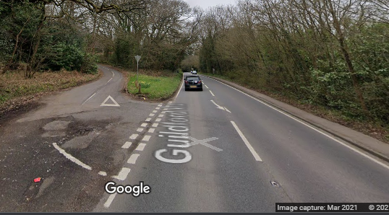  S | 0.00
LEFT TURN INTO B2126 (Marshalled) | 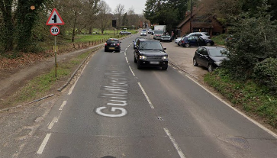 | 2.9 Miles
RIGHT TURN ONTO B2127 (Marshalled) (Give way to Left and Right) | 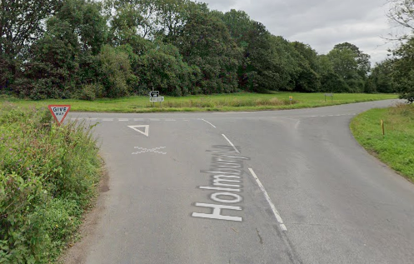 | 7.4 Miles
LEFT TURN INTO HORSHAM ROAD (Marshalled) | 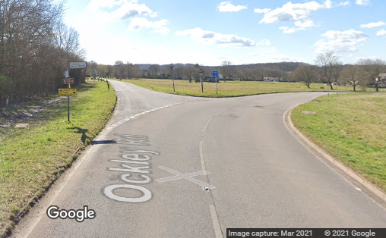 | 7.6 Miles
LEFT TURN INTO OAKWOODHILL (Marshalled) | 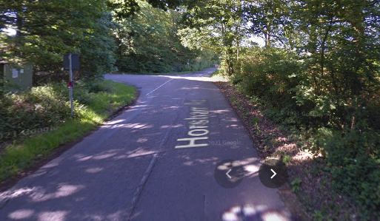 | 9.8 Miles
BEAR LEFT AT JUNCTION WITH HONEYWOOD LANE (Give way to Right) (Marshalled) | 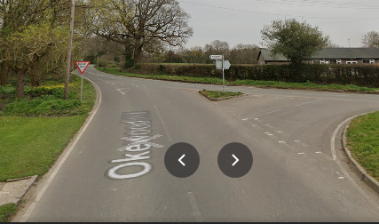 | 10.7 Miles
LEFT TURN ONTO A29 NORTHBOUND (Marshalled) (Give way to Right) | 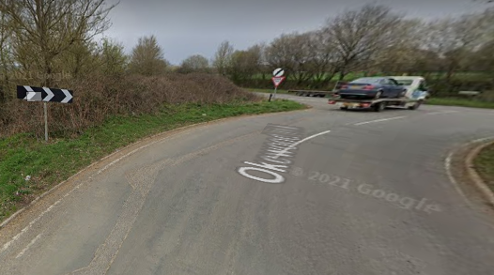 | 11.4 Miles
LEFT TURN AT ROUNDABOUT ONTO A24 NORTH (Marshalled)(Give way to Right) | 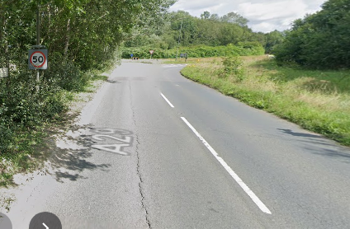 | 15.6 Miles
FINISH AT RED CHILLI (Continue straight on towards Dorking and HQ, do not stop at the Finish) | 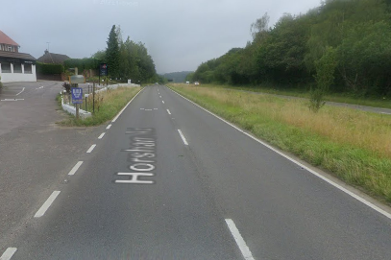 | 18.0 Miles

RETURN ROUTE TO HEADQUARTERS IN WESTCOTT | 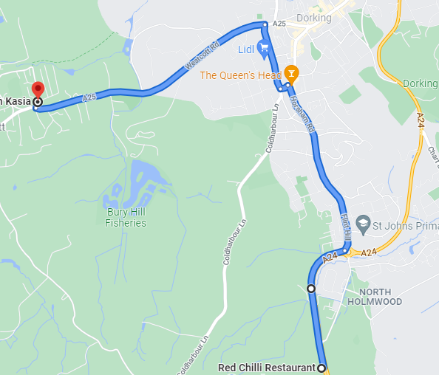 | 3.3 Miles
